CHEMICAL ENGINEERING TRANSACTIONS  VOL. , 2023 | A publication of
The Italian Association
of Chemical Engineering
Online at www.cetjournal.it

Guest Editors: Laura Piazza, Mauro Moresi, Francesco Donsì
Copyright © 2023, AIDIC Servizi S.r.l.
ISBN 979-12-81206-01-4; ISSN 2283-9216

Electrohydrodynamic Drying Technology for Heat Sensitive Foods
Alex Martynenko*, Tadeusz Kudra
Department of Engineering, Dalhousie University, Truro, NS, B2N 5E3, Canada
alex.martynenko@dal.ca

Electrohydrodynamic (EHD) drying refers to the removal of water from a wet material exposed to a strong electric field due to the aerodynamic action of so-called "ionic" or “corona” wind. This action disturbs the gas boundary layer at the material interface, decreasing convective mass transfer resistance and promoting convective mass transfer from the material. The advantage of EHD technology is the direct use of electric energy for water evaporation at ambient temperature, and therefore it could be used for drying heat-sensitive foods.
Due to zero heat generation, the energy consumption of EHD drying is very low, about 20-25 times smaller than equivalent thermal drying. Lab-scale research confirmed multiple benefits of this innovative technology, such as high drying rate, high energy efficiency, premium product quality, no GHG emissions, and low capital and operational costs. This paper contributes to the application of innovative EHD drying in combination with other drying technologies to improve the overall efficiency of heat-sensitive food drying. This application is illustrated with the experimental results of EHD drying of apple slices. The clean and eco-friendly nature of EHD technology in conjunction with premium product quality makes it a good alternative for future food engineering.
  - Introduction
Electrohydrodynamic (EHD) drying is an emerging drying technology with minimal environmental impact and reduced energy consumption as compared to thermal drying yet securing the product quality. The principle of EHD technology stems from the aerodynamic action of the so-called "corona" or "electric" wind. This wind originates either from a sharp discharge electrode (usually pin/needle or horizontal wire), electrically charged with high-voltage AC or DC of either polarity. The resulting corona wind is composed of ionized air molecules, neutral molecules, and electrons that all drift from the discharge electrode and impinge the surface of a dried material usually placed on a flat collecting electrode. This corona wind is low-power cold plasma, accelerated in the strong electric field.
The principle of EHD drying differs from the other applications of the high-voltage electric field, such as pulsed electric field (PEF), dielectric barrier discharge (DBD), or cold plasma sterilization. In contrast with the above mentioned technologies, EHD is a low-energy application, mostly focused on the gas-material interface. Corona wind disturbs the saturated boundary layer at the air-material interface, thus facilitating heat transfer and evaporation from the material surface (Martynenko and Kudra, 2016). The efficiency of EHD for drying heat-sensitive foods was proved by numerous experimental studies (Liang and Ding, 2006; Bai et al., 2012; Dinani et al., 2014; Paul and Martynenko, 2022). The success in experimental research boosted theoretical studies of the EHD phenomenon, mostly directed at the discovery of the underlying mechanisms of heat and mass transfer (Defraeye and Martynenko, 2018) and scaling-up EHD drying from the lab to industrial applications (Onwude et al., 2021). In the last decade, the number of theoretical and experimental studies of EHD drying worldwide is rapidly increasing, which indicates increasing interest in this innovative drying technology.
Figure 1 illustrates the principle of generation of the corona with the single pin-type emitter and the picture of corona wind taken in the dark using a high-resolution (1388 × 1038) monochromatic camera by shutting a series of still images at the rate of 15 frames per second. Details of such visualization are given in the paper by Bashkir and Martynenko (2021).
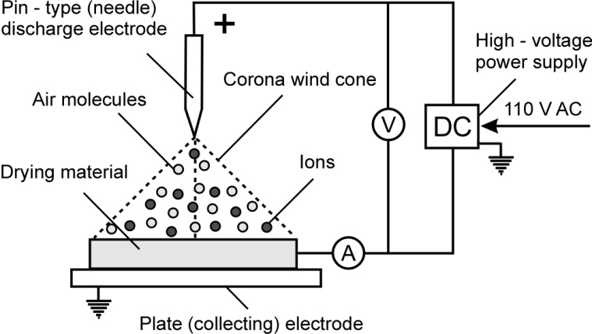

Figure 1. Principle of corona wind generation by the single emitter and photo of the corona wind.
A visible bright spot at the tip of the emitter indicates the ionization region. Deflection of the jet of corona wind results from the aerodynamic impact of the tangential stream of the secondary air. Due to the nature of corona wind, EHD drying is considered convective drying. However, the drying performance of electrically-driven EHD flow is much higher than mechanically-driven convective flow (Martynenko et al., 2020). It could be attributed to the specific vortex-like structure of the EHD flow. The ability of EHD forces to increase instability and fluid circulation at the interface of two phases was demonstrated by Jalaal et al. (2013).
Further research (Martynenko and Kudra, 2022) revealed other factors affecting the performance of EHD drying:
1. Electrical characteristics: AC or DC voltage, polarity, current, modulation, mode of discharge, etc.
2. Geometry of discharge and collecting electrodes. It includes the material and number of needles/wires, spacing, arrangement, gap, and Warburg angle of emission. The collecting electrode is usually a flat solid or perforated plate or stainless steel mesh, characterized by wire diameter and open area.
3. Environmental conditions: air temperature, humidity, pressure, airflow rate.
4. Material properties: moisture, porosity, capillarity, diffusivity, shrinkage, equilibrium moisture content.
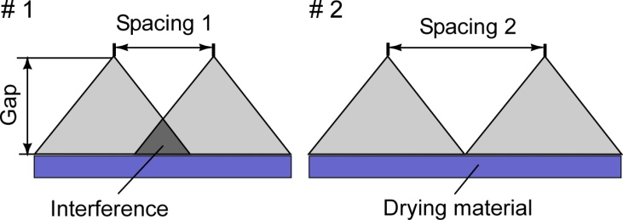
Considering future industrial applications, the multi-pin and multi-wire discharge electrodes were extensively studied to find the optimal configuration regarding the spacing between emitters, their mutual arrangement as well as the gap between the surface of the drying material and the tip of the emitters.

Figure 2. Conical corona wind jets with different spacing of two pin-type emitters (# 1 and # 2), and the trace of multiple corona wind jets on drying materials in regular (a) and staggered (b) arrangement.

From Figure 2 it follows that the most favorable spacing between the pin-type emitters for a given gap between the tip of the emitter and the drying material occurs when the projection of the bases of cones are almost touching each other either in a regular (a) or staggered (b) arrangement (Kudra and Martynenko, 2015; Martynenko et al., 2017; Martynenko and Kudra, 2020; Bashkir and Martynenko, 2021). The same rule applies to the horizontal wire-type emitters where the impact area of the corona wind on the drying material resembles the rectangle. Even though the wire emitters offer better coverage of the drying material by the corona wind, most lab-scale experiments have been carried out with pin-type emitters (Martynenko et al., 2021). It could be concluded that using wires instead of pins will simplify the construction of the electrode system and therefore it is a better match for the industrial scaling of EHD drying technology.
The effect of EHD on drying time, energy efficiency, and product quality is already well explored, however, the industry is reluctant to adopt this emerging technology as it. As an alternative, EHD could be used to facilitate convective mass transfer in other drying technologies. This application of EHD in combination with other drying technologies could gain the trust of EHD drying and accelerate its industrial application. The contribution of this paper is mostly related to the exploration of opportunities for EHD-assisted drying in intermittent or hybrid modes.
3. EHD in combination with other drying technologies
In general, hybrid technology systems combine two or more technologies aiming to achieve the required target such as energy savings, decreased GHG emissions, or reduced carbon footprint. Aside from these overall objectives, the goal of drying is to obtain the product of desired quality at reduced processing costs. In this respect, these particular objectives can be attained using EHD-based hybrid technologies. The components of hybrid technologies can be applied simultaneously or sequentially. So far, most EHD applications are reported in combination with convective hot air drying (Liang and Ding, 2007; Dinani et al., 2014; Elmizadeh et al., 2017; Polat and Izli, 2022). Wong and Lai (2004) studied the efficiency of EHD drying in combination with contact heating. Recent research reported EHD application in combination with heat pump drying (Lee et al., 2021; Meng et al., 2023). Bai et al. (2012) reported the efficiency of EHD as a pretreatment before freeze drying, while Mirzaei-Baktash et al. (2022) explored the effect of ultrasound before EHD application. In this section, we will discuss all these applications as well as the potential of EHD-assisted solar and microwave drying.
3.1. EHD-assisted convective drying
The coupling of EHD flow with the convective mass transfer is a promising approach to improve the drying operation. Many studies have confirmed the better performance of EHD-assisted thermal drying compared to sole hot air drying. Most of them considered the EHD as a supplementary tool to facilitate heat and mass transfer in thermal drying. Since the positive effect of the EHD flow is reduced at elevated air temperatures, most of the existing prototypes of EHD dryers keep the air temperature in the range of 36 to 42°C (Liang and Ding, 2007). Interestingly, the specific energy consumption of these dryers is in the range of 4800-9360 kJ/kg, whereas the equivalent thermal drying requires temperatures of about 60ºC with an energy consumption of 465960-871200 kJ/kg which is 93-97 times higher.
Further research on EHD-assisted convective drying proved that EHD application significantly decreased energy consumption at 45ºC (Dinani and Havet, 2015) and even 60ºC air temperature (Dinani et al., 2014). The savings of thermal energy have been proportional to the applied voltage, which is associated with shorter drying time and reduced heat losses. These findings have been confirmed by Elmizadeh et al. (2017) for EHD-assisted convective drying of quince slices who reported that the specific energy consumption (SEC) in thermal drying at 70ºC dropped from 470310 kJ/kg to 16790, 13350, and 9650 kJ/kg with EHD at the voltage 5, 6, and 7 kV, respectively. Results on the energy efficiency of EHD-assisted convective drying are summarized in the paper by Martynenko et al., 2021.
The reduction in thermal energy consumption due to EHD application could be expressed as the energetic advantage ($EA$) of EHD-assisted convective drying. This dimensionless indicator could be calculated using the following equation:
$$EA=\frac{E_{T}-E_{T+EHD}}{E_{EHD}} (1)$$
where $E_{T}$, $E_{EHD}$, and $E_{T+EHD}$ represent respectively the energy (kJ/kg) in thermal, sole EHD, and combined drying. The energetic advantage of EHD-assisted convective drying ranges from 48 to 226 (Martynenko et al., 2021). It increased with the temperature of thermal drying, reflecting a relatively stronger effect of EHD over a shorter drying time.
It is important to mention that EHD-assisted convective drying implies simultaneous action of EHD and hot-air stream. The interaction between these two driving forces has never been explored. Further exploration of this approach requires a study of the temperature and airflow effects on the EHD drying efficiency. In the case of the simultaneous application of EHD and hot air drying (HAD), it is essential to find the optimal conditions, where both technologies are synergetic. In the case of sequential application, it is important to find the optimal moisture content for switching from EHD to HAD and vice versa, which will reduce energy consumption and improve product quality.
From this brief analysis, it follows that the simple combination of EHD with hot-air convection is one of the avenues to go. EHD could increase the drying rate in hot air drying and therefore decrease drying time. However, any thermal drying technology is not energy-efficient because of potential heat losses. It looks like the sole EHD, without complementary heat or airflow, is the most energy-efficient, since all discharge energy is used only for water extraction. It appears the application of EHD could be a viable option in combination with other non-thermal techniques, such as heat pump drying, or solar drying. However, it should be noted that any added process (except for "energy-free" solar drying) decreases the energy efficiency of EHD drying (Martynenko et al., 2021). Sequential or intermittent application of EHD in convective drying could potentially save a significant amount of energy, albeit this approach requires thorough examination.
3.2. EHD drying with auxiliary contact heating
It is commonly recognized that EHD drying is the most efficient at ambient air temperature because additional heating by convection or radiation suppresses the EHD positive effect, thus reducing the efficiency of EHD drying (Elmizadeh et al., 2017). The negative effect of convective/radiative heat transfer results from increased entropy on the air-material interface (Martynenko and Kudra, 2016). In contrast, contact heating of a drying material could facilitate EHD-induced mass transfer (Wong and Lai, 2004). A positive effect of contact heating was observed when the heat flow direction was aligned with the mass flow. This phenomenon could be attributed to increased thermodiffusion, overcoming the limits of EHD drying with predominantly convective mass transfer mode. Although auxiliary heating dramatically increases specific energy consumption from 172-192 kJ/kg to 2000-3350 kJ/kg, this increase was still slightly smaller compared to the energy consumption of the most efficient thermal drying technologies ranging from 3000 to 5700 kJ/kg (Wong and Lai, 2004).

3.3 EHD-assisted heat pump drying
The research on EHD-assisted heat pump (HP) drying showed the potential for the simultaneous application of these two low-temperature drying technologies. EHD-assisted drying at a temperature of 22ºC and 34% RH reduced drying time by 31.6% as compared to sole HP drying (Lee et al., 2021). This effect could be attributed to the EHD-induced augmentation of a pressure-driven mass transfer. Based on a similar drop in energy consumption, these researchers concluded that EHD application could reduce HP drying costs by up to one-third. Interestingly, increasing the air temperature to 31ºC significantly increased energy consumption by almost 83%. Therefore, EHD-assisted heat pump drying is justified at ambient temperature, but not recommended in combination with additional air heating. Another example is the combined heat pump-electrohydrodynamic (EHD) drying of banana and yam slices (Meng et al., 2023). Compared with the single HP drying, the combined drying reduced the energy consumption by approximately 27.8% and drying temperature by approximately 5ºC, which saved product quality (the sensory score increased by 21.4%).

3.4 EHD-assisted solar drying
Similar to heat pump drying, solar drying is a low-temperature process. The radiation from the sun and low humidity create favorable conditions for additional application of EHD, which could intensify convective heat and mass transfer from the surface of dried material. Considering the low-energy requirements of EHD, part of solar energy could be captured by a series of photovoltaic collectors and used directly in a high-voltage converter. With the efficiency of converters in the range of 40-60% and EHD power requirements of about 30 W/m², EHD-assisted solar drying could become a viable stand-alone technology, which could be successfully used in remote locations, not connected to the power grid. The choice of alternatives depends mostly on the climate conditions and availability of solar energy. The undisputable benefit of EHD-assisted solar drying is its portability and a self-sufficient power supply well suited for developed and developing countries with vast solar irradiation.
3.5 EHD as a pretreatment before freeze drying
The application of EHD as a pretreatment before freeze drying (FD) of sea cucumbers was developed by Bai et al. (2012). They proposed a two-stage process with EHD on the first stage of drying (until the moisture content reaches 40% wb), followed by the FD to the final moisture content (12% wb). This sequential processing significantly reduced drying time and energy consumption from 168 MJ for FD to 113.2 MJ per kg of evaporated water (32% energy savings). EHD application before FD has resulted in lesser shrinkage, higher protein content, and higher sensory scores compared to sole EHD. At the same time, the quality of the dry product was comparable with conventional freeze drying.
3.6 EHD-assisted microwave drying
Even though there are no reported applications of EHD-assisted microwave drying, their simultaneous action could be quite complementary, especially for thick materials. The thickness of the material is a limiting factor for diffusion in EHD drying (Paul and Martynenko, 2022), but microwave volumetric heating could overcome this limitation. MW-induced heat generation, especially intensive in the water-saturated spots, facilitates mass transfer inside the material by thermo-diffusion as well as internal mass transfer from the material core due to a co-directed internal pressure gradient. Therefore, one can expect that intermittent MW application could complement EHD drying in a falling rate period. At the same time, EHD could mitigate deficiencies of MW drying, such as non-uniform heat distribution inside the wet material (Raghavan et al., 2005). Considering the relatively high efficiency of transforming microwave energy into heat, it will not add too much to energy consumption. So, the combination of EHD and MW appears to be considered a technology of choice since it does not contribute a lot to energy loss. Additionally, both technologies are based on the direct application of electricity, so this hybrid technology could be easily implemented by industry.

4. Case study of EHD drying
The efficiency of electrohydrodynamic drying of heat-sensitive foods was demonstrated with the case study of apple slice drying. The slices of 1 to 4 mm thickness were dried at 22 kV and a 4 cm gap with a 32-pin discharge electrode. The details of the experimental setup and methodology could be found in (Paul et al., 2022). The effect on visual quality attributes, such as shrinkage and color, was measured using a machine vision technique and compared with hot air drying. The drying kinetics was measured by continuous weighing of the tray with 56 square apple slices. The energy efficiency of drying technology was quantified by specific energy consumption (SEC) in kJ/kg of evaporated water. Drying kinetics and SEC during apple slice drying are shown in Figure 3.
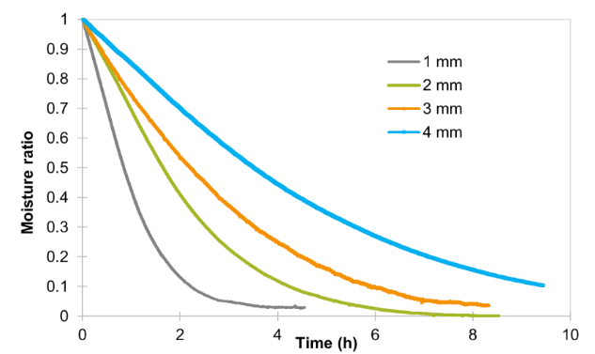
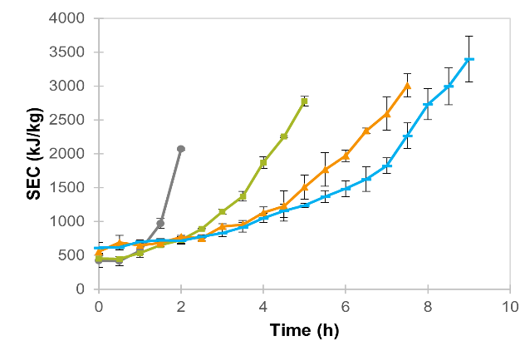
Figure 3. Drying kinetics and specific energy consumption (SEC) of apple slices with different thicknesses (from)
As could be seen from Figure 3, the SEC is not constant over the drying cycle, increasing from 450-750 kJ/kg in the period of constant rate drying to 3000-3500 kJ/kg at the end of drying. This trend is increasing for thicker slices, which could be attributed to increased diffusive resistance. In this situation, the application of HAD could benefit drying in a falling rate drying period.
Not too many research papers published on this topic. It is still an underexplored area and future research should be focused on finding the optimal moisture content, where EHD should be replaced/assisted with other technology, such as contact heating, microwave, or ultrasound to facilitate water diffusion to the surface of the material. The application of EHD at this period of drying should be limited to avoid the formation of air void at the material interface, which would significantly increase diffusive resistance. In any case, the convective mass transfer should be synchronized with diffusive mass transfer to provide continuity in water flow. One of the best indicators of the mass-transfer mode is the dimensionless Biot number (Bi_{m}), which reflects the ratio between diffusive to convective mass-transfer resistances:
$${Bi}_{m}=\frac{h_{m}L}{D} (2)$$
where h_{m} is the convective mass-transfer coefficient, m/s; D is diffusivity, m²/s; and L is material thickness, m.
The advantage of this approach is that all values in Equation 2 could be measured or calculated in real time, which creates an opportunity for process optimization. For example, the convective mass transfer coefficient is calculated from the drying rate in the constant drying rate period as:
$$h_{m}=\frac{\dot{m}}{A(c_{a}^{sat}-c_{a})}=\frac{\dot{m}}{Ac_{a}^{sat}(1-RH)} (3)$$
where $\dot{m}$ is drying rate, g/s; $A$ - area of evaporation, m²; $c_{a}^{sat}$ – concentration of water vapor at saturation, corresponding to drying temperature, g/m³; $RH$ -relative humidity.
Effective mass diffusivity could be evaluated by exponential approximation of the normalized drying curve (Figure 3a):
$$D_{eff}\left(t\right)= \frac{-4L^{2}}{π^{2}t}ln⁡({\frac{π^{2}}{8}MR)} (4)$$
where MR is the dimensionless moisture ratio and t is the drying time (s).
Also, the Biot number could be evaluated using AI models, for example, a genetic algorithm (Gornicki et al., 2019). Real-time dynamic optimization of the EHD drying process becomes possible by continuous monitoring of the Biot number and keeping it close to 1 by fine-tuning control variables (temperature and airflow).
This case study confirmed that EHD drying was beneficial for retaining the quality of apple slices with less browning compared to hot-air dried samples. The smallest color changes and browning in EHD-dried apple slices were observed for thick (4 mm) ones.

5. Conclusions
EHD drying is a revolutionary technology with the potential to improve the quality of drying heat-sensitive foods and considerably decrease energy expenses in the drying industry. Due to the low energy consumption, EHD could be used in the period of constant rate drying and then in “hybrid mode” to improve the efficiency of hot air convective drying. Due to the relatively low capital and operational costs and zero environmental pollution, EHD is recognized as a “clean” technology, a viable alternative to commonly used thermal drying. In conjunction with renewable sources of energy, it could be used as a stand-alone technology with applications from water desalination to heat-sensitive food drying.

References
Bai Y., Yang Y., Huang Q., 2012, Combined electrohydrodynamic (EHD) and vacuum freeze drying of sea cucumber, Drying Technology, 30, 10, 1051-1055.
Bashkir I, Martynenko A., 2021, Optimization of multi-emitter discharge electrode for electrohydrodynamic (EHD) drying, Journal of Food Engineering, 305, 110611-1 ─110611-12.
Dinani S. T., Havet M., Hamdami N., Shahedi M., 2014, Drying of mushroom slices using hot air combined with an electrohydrodynamic (EHD) drying system. Drying Technology, 32, 5, 597-605.
Dinani S.T., Havet M., 2015, The influence of voltage and airflow velocity of combined convective-electrohydrodynamic drying system on the kinetics and energy consumption of mushroom slices, Journal of Cleaner Production, 95, 1, 203-211.
Defraeye T., Martynenko A., 2018, Electrohydrodynamic drying of food: New insights from conjugate modeling. Journal of Cleaner Production, 198, 269-284.
Elmizadeh A., Shahedi M., Hamdami, N., 2017, Comparison of electrohydrodynamic and hot-air drying of the quince slices. Innovative Food Science & Emerging Technologies, 43, 130-135.

Gornicki K., Winiczenko R., Kaleta A., 2019, Estimation of the Biot Number using genetic algorithms: Application for the drying process. Energies 12, 2822.

Jalaal M., Khorshidi B., Esmaelzadeh E., 2013, Electrohydrodynamic (EHD) mixing of two miscible dielectric liquids, Chemical Engineering Journal, 219, 118-123.
Kudra T., Martynenko A., 2015, Energy aspects in electrohydrodynamic drying, Drying Technology, 33, 1534-1540.
Lee Y.H., Chin S-L., Chung B.K., 2021, Drying characteristics and quality of lemon slices dried under Coulomb force-assisted heat pump drying. Drying Technology, 39, 6, 765-776.
Liang Y.Z., Ding C.J., 2006, Drying with a high electric field (HEF), in "Modern Drying Technology", Y. Pan, X. Wang, X. Liu, Eds., Chemical Industry Press, Beijing, China, 840-858.
Martynenko A., Kudra T., Yue J., 2017, Multipin EHD dryer: effect of electrode geometry on charge and mass transfer. Drying Technology, 35, 16, 1970-1980.
Martynenko A., Kudra T., 2016, Electrically-induced transport phenomena in EHD drying-A review, Trends in Food Science and Technology, 54, 63-73.
Martynenko A., Kudra T., 2020, Electrohydrodynamic drying, in "Advanced Drying Technologies for Foods" eds. A.S. Mujumdar, H-W. Xiao, CRC Taylor and Francis, 1-29.
Martynenko A., Bashkir I., Kudra T., 2021, The energy efficiency of electrohydrodynamic (EHD) drying of foods, Trends in Food Science and Technology, 118, 744-764.

Meng Z., Cui, X., Zhang, H., Liu, Y., Wang, Z., Zhang, F., 2023, Study on drying characteristics of yam slices under heat pump-electrohydrodynamic combined drying. Case Studies in Thermal Engineering, 41, 102601.
Mirzaei-Baktash H., Hamdami N., Torabi, P., Fallah-Joshaqani, S., Dalvi-Isfahan M., 2022, Impact of different pretreatments on drying kinetics and quality of button mushroom slices dried by hot-air or electrohydrodynamic drying, LWT- Food Science and Technology, 155, 112894.
Onwude D.I., Iranshahi K., Rubinetti D., Martynenko A., Defraeye T., 2021, Scaling-up electrohydrodynamic drying for energy-efficient food drying via physics-based simulations, Journal of Cleaner Production, 329, 129690.
Paul A., Martynenko A., 2022, The effect of material thickness, load density, external airflow, and relative humidity on the drying efficiency and quality of EHD-dried apples, Foods, 11, 18, 2765-1─2765-19.
Raghavan G.S.V., Rennie T.J., Sunjka P.S., Orsat V., Phaphuangwittayakul W., Terdtoon P., 2005, Overview of new techniques for drying biological materials with emphasis on energy aspects, Brazilian Journal of Chemical Engineering, 22, 2, 195-201.
Wong D.S., Lai F.C., 2004, EHD-enhanced drying with auxiliary heating from below. Journal of Energy Resources Technology, 126, 133–139.

